Name ____________KEY____________________ Period: __________________________Date:_____________________
Meiosis Study Guide

- What are the two types of reproduction? What is the difference between the two types?
Sexual- Two parents, offspring are genetically different
Asexual- One parent, offspring are clones (genetically identical to parent)

- Draw a picture of a chromosome

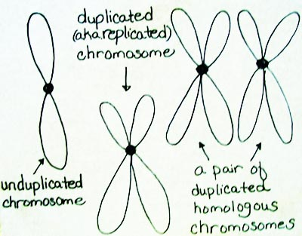

- What are homologous chromosomes?

A pair of chromosomes that have similar shapes, sizes, and genetic information

- What is the difference between a haploid and diploid cell?

Haploid- one set of chromosomes (N)
Diploid- two set (pair) of chromosomes (2N)

- For each of the following state if the cell is haploid or diploid.
Sperm cell = Haploid
Liver cell = Diploid
Egg cell = Haploid
Stomach cell = Diploid
- If the diploid number in a liver cell is 52, how many chromosomes are there in the egg of this organism? __________26________________
- The combination of a _______sperm_________ and an ___________egg________ produces a zygote with 46 chromosomes.
- During meiosis, the chromosome number:
a) is doubled
b) is reduced
c) remains the same
d) becomes diploid
- Meiosis produces haploid reproductive cells called _________gametes____________.
- Name the 2 human gametes & tell their chromosome number.
Sperm cell = 23 chromosomes- Haploid
Egg cell = 23 chromosomes- Haploid

- How many times do cells divide during meiosis?

Twice

- What are the stages of meiosis called?
Meiosis I:
Prophase I, Metaphase I, Anaphase I, Telophase I

Meiosis II:
Prophase II, Metaphase II, Anaphase II, Telophase II

- What is a tetrad?

Structure containing 4 chromatids (or 2 homologous chromosomes) that forms during Meiosis

- Which of the following best describe the term “crossing over”?
  - An exchange of information between two homologous chromosomes
  - A molecular interaction between two sister chromatids
  - A molecular interaction between two non-sister chromatids
  - A separation of two sister chromatids
- What type of material is exchanged during crossing-over? _______Genes/ Genetic Material/ DNA___________
- Crossing-over occurs in which stage of meiosis?
  - Prophase I

  - Prophase II
  - Anaphase I
  - Anaphase II
- How many cells are formed at the end of Meiosis I & how many copies of chromosomes does each cell have?
Two cells with N chromosomes (For example, in humans each cell would have 23 Chromosomes seen a sister chromatids)

- Is DNA copied before Meiosis II?

NO!

- How many cells form at the end of Meiosis II and how many chromosomes do they contain?

Four cells with N Chromosomes (For example, in humans the cells would have 23 Chromosomes)

- A sperm cell is a (gamete, zygote), and is (haploid, diploid).

- When a sperm cell and an ovum merge, they undergo the process of fertilization, and give rise to a (gamete, zygote), which is (haploid, diploid).
- A hypothetical organism has 10 chromosomes for each of its body cells.
  - Skin cells are continuously being rubbed off and replaced. How many chromosomes will be contained in each new skin cell that is replaced? ____________10________________
  - This replacement occurs through the process of ________Mitosis___________________________.
  - The diploid number (2N) for this organism is _______________10________________________.
  - This organism would have how many homologous pairs of chromosomes? ________________5___________________________________
  - The mature eggs of this female would contain how many chromosomes? _______5_________________

